Goal- To delay cord clamping in all eligible infants for at least 30, preferably 60 seconds after birth.

Indication- All live born infants, unless there is a contra-indication.

Contra-indications-
Maternal:
- Hemorrhage
- Cardiovascular instability
Neonatal:
- Placental abruption, Previa, Cord prolapse
- Hydrops
- Monochorionic twin gestation (risk of acute intertwin transfusion at birth)
- HIV + mother with unknown or high viral load (> 1000 copies/ml) or did not received treatment in pregnancy ^{1,2}
- Critical³ CHDs that are more likely to require immediate resuscitation (HLHS with RAS, d-TGA with RAS, obstructed TAPVR) ^{4,5}
- Known severe congenital anomaly with anticipation for immediate resuscitation- CDH, CCAM, lethal skeletal dysplasias
- Other congenital anomalies- decision to be individualized
- Known genetic abnormalities- decision to be individualized
- IUGR with reversed end diastolic flow- Discuss utility with OB
- CS under general anesthesia???

Note: Meconium, non-reassuring fetal tracings are NOT contra-indications. Most of these babies do well. Initiate DCC and monitor as per protocol.

1 WHO Guideline: Delayed Umbilical Cord Clamping for Improved Maternal and Infant Health and Nutrition Outcomes. Geneva: WHO; (2014).

2 Italian Recommendations for Placental Transfusion Strategies
Stefano Ghirardello,^{1,*} Mariarosaria Di Tommaso,² Stefano Fiocchi,³ Anna Locatelli,⁴ Barbara Perrone,⁵ Simone Pratesi,⁶ and Paola Saracco⁷

3 Critical CHDs (defined as any CHD that can potentially require surgical intervention in 1st month). Main concerns- Volume overload, polycythemia (increased risk of shunt blockage), perceived need for immediate resuscitation.

4 Early versus delayed umbilical cord clamping in infants with congenital heart disease: a pilot, randomized, controlled trial
CH Backes,^{1,2,3,4} H Huang,^{1,3} CL Cua,^{2,3} V Garg,^{2,3,5} CV Smith,⁶ H Yin,⁷ M Galantowicz,^{2,3,8} JA Bauer,^{1,3} and TM Hoffman^{2,3}-
The only study where they tested DCC for cirtical CHDS (excluding all single ventricle physiology lesions)

5 Timing of umbilical cord clamping among infants with congenital heart disease
Laura Marzec, IMG,^{a,*} Eli Zettler, BS,^{a,*^} Clifford L. Cua, MD,ª Brian K. Rivera, MS,ª Sara Pasquali, MD,^{b} Anup Katheria, MD,^{c} and Carl H. Backes, MD^{a,d,e}

Set up-
- Prepare to perform DCC for every infant unless there is a contra-indication. When contra-indicated, it should be discussed prior to delivery. Either the OB provider (in case of maternal contra-indication) or the neonatal provider (in case of neonatal contra-indication) will bring this up prior to the delivery so that the team is prepared to clamp the cord immediately.
- Delivery room(DR)/Operating room(OR) temperature set at 72/75(to prevent hypothermia in infants)
- Timekeeper identified and named (someone in NICU team)

- Neonatologist, neonatal fellow or neonatal nurse practitioner at maternal bedside

- Sterile pre-warmed blankets for C-section and warm blankets and cap for vaginal delivery to be available and ready

Procedure-
- For CS delivery, during time out, if any, contraindication for DCC to be discussed. For vaginal delivery, this will be done upon arrival of the NICU team. Unless specified and discussed otherwise, DCC to be performed for every delivery.
- Once the skin incision made- the circulating nurse will get the warm sterile baby blanket from the warmer and place it under the radiant warmer
- Once the uterine incision is made, the circulating nurse will hand over the sterile blanket to the OB tech.
- Once the delivering OB announces the delivery of infant, the Apgar timer on the bed to be started by NICU nurse and the timekeeper should verbally announce time in 15 seconds intervals.

  - Infant should be wrapped in the sterile towel for CS and placed between the thighs. For vaginal delivery, place the infant on the mother’s abdomen for skin to skin. Cover the head with a cap.

  - The OB nurse/physician will stimulate and suction the baby during the process if needed.

  - NICU fellow/NNP will be at the bed side to monitor the baby.
  - Cord clamp applied after 60 seconds and neonate handed over to the NICU team.
  - Cord clamp time (in seconds) should be recorded in the mother’s and baby’s medical records.

  - Record the infant’s temperature at 5 min.

Monitoring-
- During the delayed cord clamping, the neonatologist will visually assess the baby for spontaneous respirations.
- The OB nurse/physician will provide stimulation to the baby to help establish spontaneous respirations during vaginal delivery, and OBT/physician during C-section.
- At 30 seconds- assess for spontaneous respirations.

When do we stop?

The OB can make decision to stop the process if-

  - If there is sudden placental separation during any time.
  - If mother becomes hemodynamically unstable at any point during the procedure. The neonatologist can make the decision to stop DCC if-
  - No spontaneous respirations by 45 seconds

Algorithm:

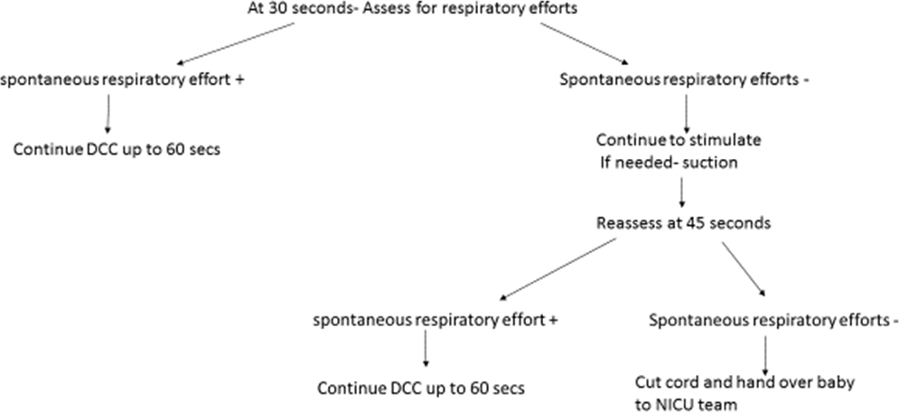

If no spontaneous respiratory efforts at 30 secs clamp the cord and hand over baby to the NICU team

- Start Apgar timer on bed with the announcement of infant’s delivery
- Announce time at 15, 30, 45, and 60 second increments
- Communication must be maintained at all times between two teams.

Role assignment- OB team:
  - During CS- the OB circulating nurse will get the sterile warm blanket from warmer and place in radiant warmer until uterine incision

  - Wrap infant in warm blanket and dry the baby.
  - Provide stimulation and suction the mouth if needed.
  - Cut/clamp cord per usual and carry the baby to the radiant warmer for the NICU team.
  - Document length of timed cord clamping (in seconds) in the L&D chart

NICU Nurse:

  - Start Apgar timer on bed with the announcement of infant’s delivery
  - Announce time at 15, 30, 45, and 60 second increments

Neonatologist/ Neonatal Fellow/ NNP:

  - At maternal bedside at time of delivery
  - For vaginal delivery, will hand over the warm blanket and the cap to the OB team for keeping infant warm

  - Assess the infant for respiratory effort
  - Proceed with standard resuscitation per NRP guidelines
  - Document in the delivery note as well as the L&D checklist

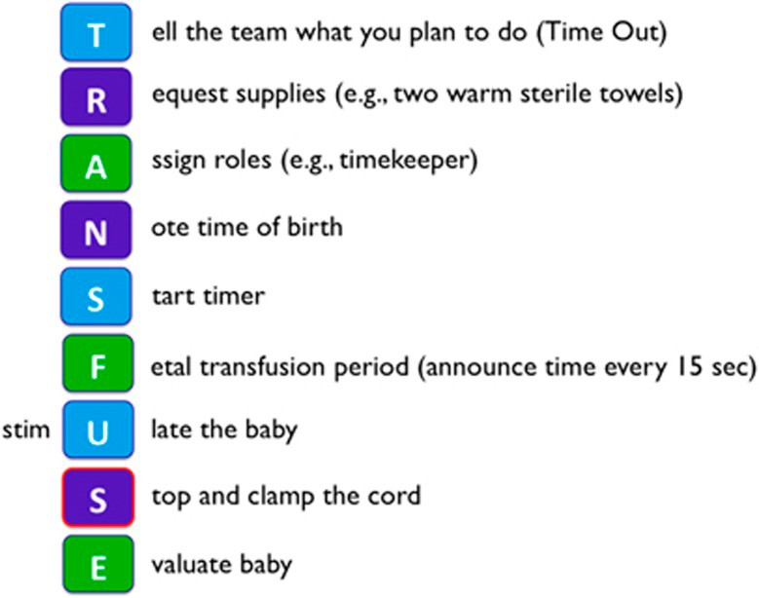

ebriefing

