Severe Maternal Hypertension – Optimizing Obstetrical Care
Tennessee Initiative for Perinatal Quality Care
Inter-Institutional Quality Improvement Project
Funded under a grant from the Tennessee Department of Health (TDH)
In Association with The American College of Obstetricians and Gynecologists (ACOG)
Alliance for Innovation in Maternal Health (AIM)

Project Development Leaders
Connie Graves, MD St. Thomas Midtown
Danielle Tate, MD Regional One Health

Tennessee Initiative for Perinatal Quality Care (TIPQC) Leaders
Brenda Barker, MEd, MBA TIPQC Executive Director
Jessica Young, MD, MPH TIPQC Maternal Medical Director
Bonnie Miller, MSN, RN TIPQC Maternal Quality Improvement Specialist
Theresa Scott, MS TIPQC Data Manager

Pilot Teams

Baptist Memorial Hospital for Women & Children
Camielle Fishel, DNP, RNC-OB

Baptist Memorial Tipton
Kim Strickland, RN

Northcrest Medical Center
Shana Dowell

Regional One Health
Abigail Combs, MD
Victoria Lyons, MD
Danylle Johnson, MSN, RN
University of Tennessee Medical Center, Knoxville
Tripp Nelson, MD
Megan Lacy, MPH
Charlotte McCarley, MD
Nikki Zite, MD
Kelsie Otten, BSN, RN, C-EFM, RNC-OB
Robin Swaggerty, MSN, FNP-BC
Becki Morrison, MSN, RN, C-EFM
Carrie White, BSN, RN, C-EFM

Vanderbilt University Medical Center
Rolanda Lister, MD

The Tennessee Initiative for Perinatal Quality Care (TIPQC) would like to thank other states who have shared and/or published their Hypertension and Preeclampsia Improvement toolkits. We have learned from your efforts and initiatives and have adapted portions from each state toolkit. Together, we can make a difference!

Specific Acknowledgments
- Tennessee Department of Health (TDH)
- Tennessee Hospital Association (THA)
- Pilot Teams –
  - Baptist Memorial Hospital for Women
  - Baptist Memorial-Tipton
  - NorthCrest Medical Center
  - Regional One Health
  - St. Thomas Midtown
  - University of Tennessee Medical Center in Knoxville
  - Vanderbilt University Medical Center
- American College of Obstetrics and Gynecology (ACOG)
- Alliance for Innovation on Maternal Health (AIM)
- Illinois Perinatal Quality Collaborative (ILPQC)
- California Maternal Quality Care Collaborative (CMQCC)

DISCLAIMER: The authors of this toolkit used reasonable efforts to provide accurate information. The information and resources included in this toolkit are provided for informational purposes only. Nothing contained herein constitutes medical, legal, or other professional advice nor does it represent an endorsement of any treatment or particular product. Referral to specific programs, resources, or websites does not imply endorsement by the toolkit’s authors or the authors’ organizations or their sponsors, contents, expressed views, programs or activities. Further, the authors do not endorse any commercial products that may be referred to in this toolkit or that may be advertised or available from these programs, resources, or websites. This toolkit is not meant to be comprehensive; the exclusion of a program, resource or website does not reflect the quality of that program, resource, or website. Please note that websites and URLs are subject to change without advanced notice.

Table of Contents
Introduction to the Toolkit 4
Charter 5
Summary of the Evidence 6
Quality Improvement Overview 8
Project Checklist – How to get started 9
Aims, Population, and Measures 10
Definitions: Types of Hypertension 11
Tool Kit 12
Potentially Better Practices (PBPs) 14
Appendix: Key Driver Diagram 21
Appendix: Additional Resources 22
References 26

Introduction to the Toolkit

This toolkit is a collection of evidence-based practices based on a review of current literature related to severe maternal hypertension (HTN). Any success realized from this toolkit is in part due to the generosity and collaborative spirit of the practices that participated in the TIPQC pilot projects, the Alliance for Innovation in Maternal Health (AIM) bundles, and toolkits from states and organizations that have successfully implemented since 2014.

Maternal hypertensive disorders though not a new threat to maternal health have garnered renewed attention around the world and have been the focus of new efforts from The Joint Commission (TJC), the American College of Obstetrics & Gynecology (ACOG) and the Society for Maternal-Fetal Medicine (SMFM) in the United States (US). There has been an expansion of research into the entire spectrum of perinatal evaluation and management of hypertension, including prenatal care, inpatient blood pressure management, postpartum follow-up, enhanced use of family support services, hospital care of the maternal-infant dyad, and the recognized need for more outcome results after discharge. This project will promote the consistent application of diagnostic and treatment bundles and protocols to optimize the outcomes of patients with hypertensive disorders of pregnancy.

This toolkit is intended for application in conjunction with learning opportunities and webinars. Included in the toolkit are guidelines and recommendations outlined by ACOG, SMFM, and TJC for 2020. As with any bundle, it is recommended the toolkit be implemented with all interventions undertaken. However, individualized institutional policy and groundwork will be required as with any system process implementation and change. TIPQC is available to discuss implementation strategies with project leaders and teams as desired or needed.

Charter

The “Severe Maternal Hypertension – Optimizing Obstetric Care Project” was selected by an inter-professional team of Tennessee obstetric and pediatric providers as part of TIPQC’s maternal arm, in conjunction with AIM. TIPQC noticed “gaps” in statewide treatment of severe maternal hypertension, preeclampsia, and eclampsia. According to The Joint Commission, the new standards for perinatal safety require organizations to look at their processes and procedures surrounding the care of women experiencing severe hypertension/preeclampsia. Equally clear, Tennessee has seen a marked increase in hypertensive-related morbidity and mortality in the maternal population in recent years, and this trend has resulted in a growing number of women who require hospital care for management of severe hypertension.

The TIPQC Maternal Arm with AIM collaborated to bring this project to fruition in Tennessee. AIM is a national data-driven maternal safety and quality improvement initiative based on proven implementation approaches to improving maternal safety and outcomes in the United States. AIM’s end goal is to eliminate preventable maternal mortality and severe morbidity across the US. AIM works through state teams and health systems to align national, state, and local, including hospital level, quality improvement efforts to improve overall maternal health outcomes. AIM is funded through a cooperative agreement with the Maternal and Child Health Bureau (MCHB)-Health Resource Services Administration (HRSA).

Stakeholders at the 2019 TIPQC Annual meeting selected the Severe Maternal Hypertension project as the focus of 2020 Quality Improvement efforts. Participating institutions will agree to the following: implementing the project as designed, collecting, and submitting the monthly data in a timely manner, and participating in monthly webinars and statewide meetings. The TIPQC Maternal Arm’s goals are to work with the medical leaders across the state to implement policies, procedures, and protocols in delivering facilities within the state of Tennessee.

Summary of the Evidence

Hypertensive disorders of pregnancy constitute one of the leading causes of maternal and perinatal mortality worldwide. It is estimated that preeclampsia complicates 2-8 percent of all pregnancies globally. Approximately 76,000 maternal deaths and 500,000 infant deaths worldwide, and 7% in the United States per year are attributed to maternal hypertensive disorders. In the United States, since 1987, hypertensive disorders have increased by 25% and are the leading drivers of maternal morbidity and mortality. According to the Preeclampsia Foundation, preeclampsia accounts for 40% of all medically necessary preterm deliveries and 75% of maternal deaths after delivery. In addition, women are four times more likely to develop Post-traumatic Stress Disorder (PTSD) due to preeclampsia¹.

High blood pressure during pregnancy poses various fetal risks, including decreased blood flow to the placenta, which decreases oxygen and fewer nutrients to the fetus, leading to placental insufficiency that can result in intrauterine growth restriction (IUGR), low birth weight, or premature birth. If left untreated, preeclampsia can lead to serious, even fatal complications for both mother and fetus. The cost burden of caring for mothers with pre-eclampsia in the United States exceeds $1 billion and $1.5 billion for infants, annually.³

The postpartum period is also a critical time for women. Preeclampsia and hypertensive disorders of pregnancy are now acknowledged as independent risk factors for later cardiovascular disease (CVD)². Obstetrician & gynecologists should ensure that women with a history of preeclampsia are transitioned to a primary care provider to help with both short-term and long-term follow-up.⁴

For decades, substantial racial and ethnic disparities in diagnosis, treatment, and outcomes have been documented. African American women are 3 times more likely to die from preeclampsia then those of other ethnicities nationwide. Additionally, in Tennessee, non-Hispanic Black women are approximately 1.4 times as likely to die within one year of pregnancy compared to non-Hispanic White women.⁵ Our goal is to bring equity and reduce disparities through timely recognition and treatment for all women.

Pregnancy
Maternal hypertension is noted as a new onset or chronic but manageable disease with medication, behavioral/diet modifications, and/or support. Prenatal care provides an excellent opportunity to identify and treat maternal hypertension. Despite the recommendation of universal screening for maternal hypertension and treatment the first prenatal visit and throughout the pregnancy, it is often not standard practice. Screening allows for identification of women who are at risk for maternal hypertensive disorder as well and aids in subsequent referral for assessment, diagnosis, and treatment. The pregnant woman may lack access to highly effective treatment, including more frequent visits, medications, and related therapies. During delivery hospitalization, care teams are required to have knowledge regarding assessment including early intervention, intrapartum and postpartum treatment, management, and psychosocial needs for the hypertensive patient. Postpartum follow up should be earlier, and more frequent visits than the traditional six-week postpartum visit. In addition, there remain high rates of unintended pregnancies among women with hypertensive disorders. There are significant differences in blood pressure prevalence and control rates based on race/ethnicity as it pertains to management of hypertension.⁶

Tennessee Information
- Ranks 6th in the country for maternal heart disease
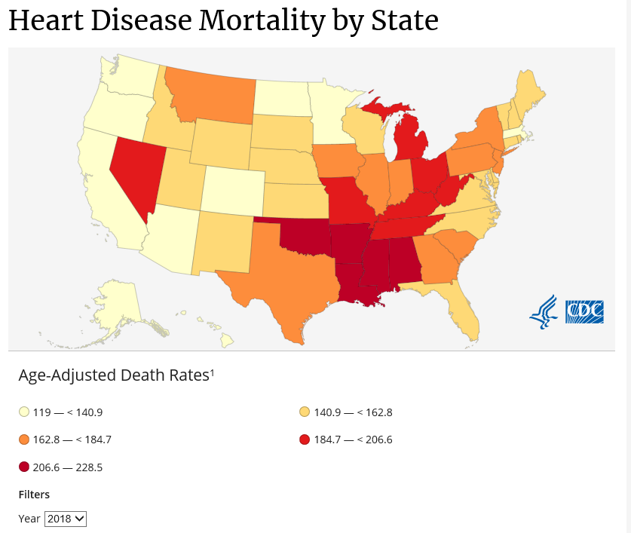
https://www.cdc.gov/nchs/pressroom/states/tennessee/tn.htm⁵
- The leading cause of death is heart disease
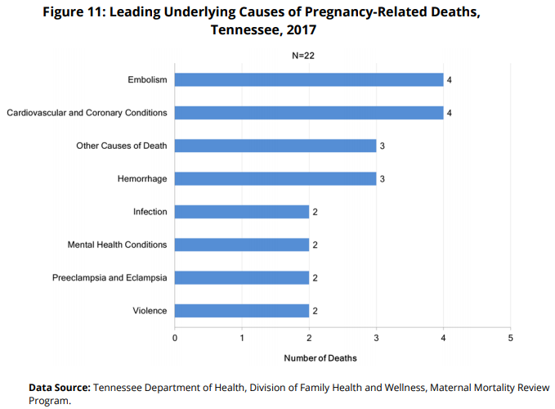

State-level quality improvement, policy, and program actions are necessary to increase recognition and treatment to lessen the effects of hypertensive disorders during pregnancy and for the newborn. The current project plans to:
- Aid facilities in the initial work
- Dive into specific components of care which may be beneficial to improving the maternal and neonatal outcomes.
- Demonstrate improved long-term care after delivery

Quality Improvement Overview

Stakeholders at the 2019 TIPQC Annual Meeting selected the Hypertension project as one of the focus areas for 2020. This decision is supported by the state’s Maternal Mortality Review (MMR) report that showed an increase in maternal deaths in Tennessee, with hypertension being one of the leading causes of maternal mortality and morbidity. Participating institutions will agree to the following:
- Implement the project as designed
- Collect and submit the monthly data in a timely manner
- Participate in monthly webinars and statewide meetings
- Data sharing from Tennessee Hospital Association to AIM

This QI Tool Kit is based on a set of evidence-based guidelines published by the American College of Obstetrics & Gynecology Task Force on maternal hypertension. There has been adoption of the guidelines by health care professionals, patients, and other health care experts. Changes in practice, guided by these evidence-based guidelines, will require testing and adaptation to the teams’ circumstances and context to achieve measured improvements in outcomes. As the teams’ test and implement these guidelines, they should monitor the results closely to ensure they are obtaining the desired results, that no harm is being done, and that no unanticipated results are seen.

Model for Improvement*
For more information, see https://tipqc.org/jit-pdsa/. *Used by permission and adapted from:
Langley, Nolan, Nolan, Norman, Provost. The Improvement Guide. San Francisco: Jossey-Bass Publishers; 1996.⁷

Project Checklist – How to get started

- Form a team (refer to TIPQC Just in Time Modules for more information: https://tipqc.org/qi/)

- Complete the TIPQC Project Application: https://tipqc.org/active-projects/

- Schedule a regular recurring (at least monthly) team meeting

- Review this tool kit – particularly the Potentially Better Practices (PBPs)

- Review the project Data Entry Guide and define your data workflow

- Research and determine your current system and needs for project implementation. Reference the Key Driver Diagram for possible interventions.

- Begin prioritizing action items with Plan, Do, Study, Act (PDSA) cycles

- Attend kick off & data training sessions

- Gather the defined baseline data and begin collecting the additional project data

- Attend monthly huddles & learning sessions

- Methodically work through planned PDSA cycles

- Capture project data

Aims, Population, and Measures

GLOBAL PROJECT AIM: To reduce the rate of severe morbidities in pregnant and postpartum women with severe hypertension by 20% by December 2021.

TARGET POPULATION: Pregnant and postpartum women (up to 6 weeks) that present to L&D, Triage, ED, Antepartum, or Postpartum that have an elevated blood pressure of ≥160 systolic and/or ≥110 diastolic twice within 15 minutes. Patients with chronic/gestational HTN should also be included.

MEASURES
I. Outcome Measures:
- Severe maternal morbidity (including and excluding transfusion codes) among
  - All mothers during their birth admission (excluding ectopics and miscarriages);
  - Preeclampsia cases, defined as all mothers during their birth admission (excluding ectopics and miscarriages) with one of the following diagnosis codes:
    - Severe Preeclampsia
    - Eclampsia
    - Preeclampsia superimposed on pre-existing hypertension

II. Process Measures:
- Obstetric (OB) maternal safety drills (number and topics)
- Provider education (cumulative proportion of delivering physicians and midwives that have completed within the last two years an education program on Severe Hypertension/Preeclampsia that includes the unit-standard protocols and measures)
- Nursing education (cumulative proportion of OB nurses (including L&D and postpartum) that have completed within the last two years an education program on Severe Hypertension/Preeclampsia that includes the unit-standard protocols and measures)
- Treatment of Severe HTN (percent of birthing patients with acute-onset severe hypertension that persists for 15 minutes or more, including those with preeclampsia, gestational or chronic hypertension who were treated within 1 hour with IV Labetalol, IV Hydralazine, or PO Nifedipine)

III. Structure Measures
- Patient, Family & Staff Support (hospital has developed OB specific resources and protocols to support patients, family and staff through major OB complications)
- Debriefs (hospital has established a system in your hospital to perform regular formal debriefs after cases with major complications)
- Multidisciplinary Case Reviews (hospital has established a process to perform multidisciplinary systems-level reviews on cases of severe maternal morbidity, including, at minimum, birthing patients admitted to the ICU or receiving ≥4 units RBC transfusions)
- Unit Policy and Procedure (hospital has a Severe HTN/Preeclampsia policy and procedure that provides a unit-standard approach to measuring blood pressure, treatment of Severe HTN/Preeclampsia, administration of Magnesium Sulfate, and treatment of Magnesium Sulfate overdose)
- Electronic Health Record (EHR) Integration (hospital has integrated at least some of the recommended Severe HTN/Preeclampsia bundle processes (i.e. order sets, tracking tools) into their Electronic Health Record system)

Definitions: Types of Hypertension

- Hypertensive emergency in pregnancy- Systolic Blood Pressure (SBP) of 160 millimeter of mercury (mm Hg) or greater—2 readings 15 minutes apart, or Diastolic Blood Pressure (DBP) of 110 mm Hg or greater –- 2 readings 15 minutes apart
- Chronic Hypertension- preexisting diagnosis of persistently elevated/high blood pressure
  - 1) elevated (systolic blood pressure of 120–129 mmHg and diastolic blood pressure less than 80 mm Hg)
  - 2) stage one (1) hypertension (systolic blood pressure of 130–139 mmHg or diastolic blood pressure of 80–89 mmHg)
  - 3) stage two (2) hypertension (systolic blood pressure of 140 mmHg or more or diastolic blood pressure of 90 mmHg or more)
- Chronic Hypertension
  - SBP greater than or equal to (≥) 140 or DBP greater than or equal to (≥)90
  - Pre-pregnancy or less than (<) 20 weeks gestation
- Gestational Hypertension (GHTN)
  - New onset hypertension after 20 weeks gestation
    - BP-140/90 on 2 separate occasions 4 hours (hr.) apart
    - Less than 300 milligrams (mg) protein in 24 hr. specimen
  - Absence of systemic signs/symptoms
- Preeclampsia
  - New onset hypertension after 20 weeks gestation
  - Preeclampsia without severe features:
    - BP- SBP ≥ 140 or DBP ≥ 90 on 2 separate occasions at least 4 hours (hr.) apart
    - Greater than or equal to 300 milligrams (mg) protein in 24 hr. specimen
    - Absence of systemic signs/symptoms
  - Preeclampsia with severe features
    - SBP ≥ 160 or DBP ≥ 110 on 2 separate occasions at least 4 hours apart unless antihypertensive management is initiated before this time
    - Progressive renal insufficiency (serum creatinine more than 1.1 mg/dL or a doubling of serum creatinine in the absence of other renal disease)
    - Unremitting headache/visual disturbances
    - Pulmonary edema
    - Epigastric/RUQ pain
    - Impaired liver function tests (LFTs) > 2x upper limit of normal (not accounted for by alternative diagnoses)
    - Thrombocytopenia (Platelet count < 100k)
    - HELLP syndrome
    - *5gr of proteinuria no longer criteria for severe preeclampsia

** Delivery recommendations²³ **

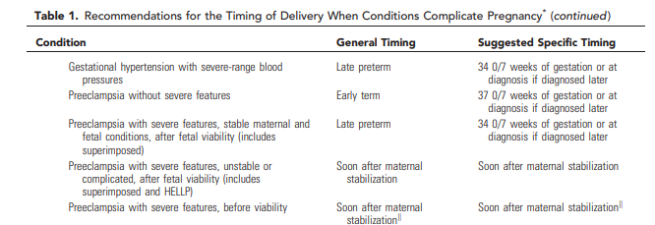

Tool Kit
https://safehealthcareforeverywoman.org/patient-safety-bundles/severe-hypertension-in-pregnancy/

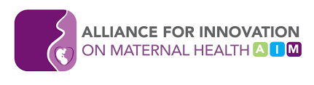 |  | Patient Safety Bundle
READINESS
Every Unit | Standards for early warning signs, diagnostic criteria, monitoring and treatment of severe preeclampsia/eclampsia (include order sets and algorithms)
Rapid access to medications used for severe hypertension/eclampsia:
  - Medications should be stocked and immediately available on Labor and Delivery (L&D) in other areas where patients may be treated. Include brief guide for administration and dosage.
 | Process for timely triage and evaluation of pregnant and postpartum women with hypertension including ED and outpatient areas
Every Unit/Health System | Provide staff-wide (clinical and non-clinical staff) education on protocols, unit-based drills (with post-drill debriefs).  - Emphasize that severe hypertension is a medical emergency that must be treated immediately
Provide training regarding hypertensive emergency care
- Establish specific prenatal, intrapartum, and postpartum clinical pathways for women with hypertension that incorporate care coordination among multiple providers
 | Develop hypertensive protocols that account for chronic HTN, gestational HTN, preeclampsia, or eclampsia
RECOGNTION AND PREVENTION
Every Provider/Unit | Standard protocol for measurement and assessment of BP and urine protein for all pregnant and postpartum women
Screen and evaluate all pregnant women with hypertension for commonly occurring co-morbidities
- Ensure the ability to screen for hypertension
- Provide resources and interventions for smoking cessation
Standard response to maternal early warning signs including:
- listening to and investigating patient symptoms
- and assessment of labs (e.g. Complete Blood Count (CBC) with platelets, Alanine Aminotransferase (ALT) and Aspartate aminotransferase (AST)
- Facility-wide standards for educating prenatal and postpartum women on signs and symptoms of hypertension and preeclampsia
- Community resource provided to patients that discusses where they can get their blood pressure taken if they do not have a cuff at home
RESPONSE
Every Provider/Unit/Health System | Facility-wide standard protocols with checklists and escalation policies for management and treatment of:  - Severe hypertension  - Eclampsia, seizure prophylaxis, and magnesium over-dosage  - Postpartum presentation of severe hypertension/preeclampsia
Minimum requirements for protocol:
- Notification of physician or primary care provider if systolic BP =/> 160 or diastolic BP =/> 110 for two measurements within 15 minutes
- After the second elevated reading, treatment should be initiated ASAP (within 30-60 minutes of confirmed severe range blood pressure)
- Includes onset and duration of magnesium sulfate therapy
- Includes escalation measures for those unresponsive to standard treatment
- Describes manner and verification of follow-up within 7 to 14 days postpartum
- Describe postpartum patient education for all women about hypertension thresholds and warning signs related to preeclampsia
Support plan for patients, families, and staff for ICU admissions and serious complications of severe hypertension
- Engage state agencies and other professionals in developing safe care protocols tailored to the patient’s hypertensive treatment and resource needs
- Guide priority access to quality home visiting services for women affected by hypertensive disorders as indicated
REPORTING AND SYSTEMS LEARNING
Every Unit/Health System | Develop mechanisms to collect data and monitor metrics to ensure high quality healthcare delivery for women with hypertension, preeclampsia, or eclampsia. Develop a data dashboard to monitor process and outcome measures (i.e. number of pregnant women treated for hypertension)
 | Create multidisciplinary case review teams to evaluate all severe hypertension/eclampsia cases admitted to ICU for systems issues
 | Develop continuing education and learning opportunities for providers and staff regarding HTN, preeclampsia, eclampsia
 | Establish a culture of huddles for high risk patients and post-event debriefs to identify successes and opportunities
 | Monitor outcomes and process metrics

Potentially Better Practices (PBPs)

Standardized, evidence-based clinical guidelines for management of patients with preeclampsia and eclampsia
- Low-dose aspirin for prevention of preeclampsia
- Treatment of severe sustained and unresolved HTN within 30-60 minutes
- IV antihypertensive medication administration for management of acute-onset of severe hypertension
- Magnesium sulfate administration for seizure prophylaxis
- Immediate release oral Nifedipine (may be considered as first-line therapy, particularly when IV access is not available)
- Documentation of care transition and education after delivery for women with gestational hypertension, preeclampsia, or eclampsia
- Disparity lens
- Follow up after delivery; assessment of long-term diagnosis/treatment; appropriate post-partum discharge instructions

PBP #1
Use of low-dose aspirin during pregnancy for the prevention of Hypertensive Disorders of Pregnancy in women at increased risk
Rationale: Although investigation of the development of preeclampsia has not fully elucidated the pathophysiology of this disease, speculation about the role of platelet metabolism of thromboxane led to the study of aspirin as a potential therapy for the prevention of preeclampsia in the 1980s.⁷ Since that time, multiple studies have been performed to evaluate the efficacy of low-dose aspirin in preventing the development of preeclampsia and fetal growth restriction as well as to evaluate the potential risks of aspirin use in pregnancy.^{8,9} At this time, review of the available evidence led to the United States Preventative Task Force to recommend the use of low-dose aspirin in women with increased risk of developing preeclampsia.¹⁰ The American College of Obstetricians and Gynecologists and the Society of Maternal-Fetal Medicine have endorsed this recommendation as well.¹¹ Specifically, the recommendation states that women with any one of the high-risk factors for preeclampsia* or those with more than one of the moderate-risk factors* should receive low-dose (81 mg/day) aspirin for preeclampsia prophylaxis, initiated between 12 weeks and 28 weeks of gestation (optimally before 16 weeks of gestation) and continuing until delivery. See Table 1.

Implementation Strategies:
- Create and provide evidence-based education for the patients and providers;
- Develop a screening tool to be administered to all patients at the initiation of care who are less than 28 weeks of gestation;
- Distribution of low-dose aspirin from the clinic or hospital at the initiation of care to decrease delay in treatment;
- Secure insurance coverage of medication and tracking of provider prescribing;
- Use of medication reconciliation via the EMR to document use of aspirin at each clinic visit;
- Referral as appropriate to high-risk obstetric providers;
- Evaluate current barriers to patients’ acquisition and compliance with daily low-dose aspirin.

Potential Challenges:
- Delay in presentation to care;
- Difficulty tracking use given the over-the-counter availability of low-dose aspirin;
- Refusal to abide by treatment recommendations;
- Lack of coordination between providers leading to delay of implementation;
- Limited healthcare prior to pregnancy and limited health literacy leading to women with undiagnosed or unrecognized risk factors.

Who: physicians, midwives, nurse practitioners, nurses, pharmacists, payors, patients

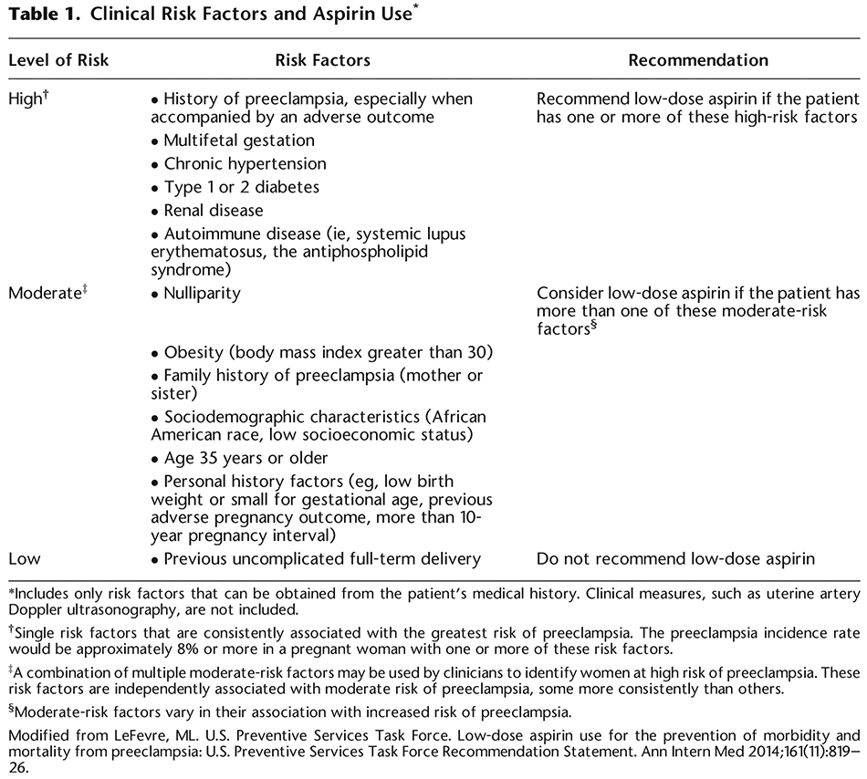

PBP #2
Treatment of severe sustained and unresolved HTN within 30-60 minutes.
- Treatment of Severe HTN within 30-60 minutes of presentation
  - Intravenous (IV) Anti-hypertensive medication administration for management of acute onset severe HTN
  - Immediate Release (IR) oral Nifedipine as first-line therapy when IV access/treatment is not available
- Pathway should be easy to follow and initiate
  - Best way for nurses to quickly initiate
  - Pathway order sets part of hospital EMRs
  - “Time-clock” component so timing is tracked and easy to identify
  - Labs (including drug screen as indicated) initiated quickly as well
- Is ideal timing 30 – 60 minutes
  - What are obstacles for obtaining 30 minutes? (pharmacy/availability of medication, volume of unit/presence of higher acuity patients)
- Should treatment be ≥160 or ≥110

PBP#3
IV antihypertensive medication administration for management of acute onset of severe hypertension
- Labetalol Onset of action 1-2 minutes
- Hydralazine Onset of action 10-20 minutes
- Nifedipine Onset of action 5-10 minutes
- Nicardipine Onset of action-immediately
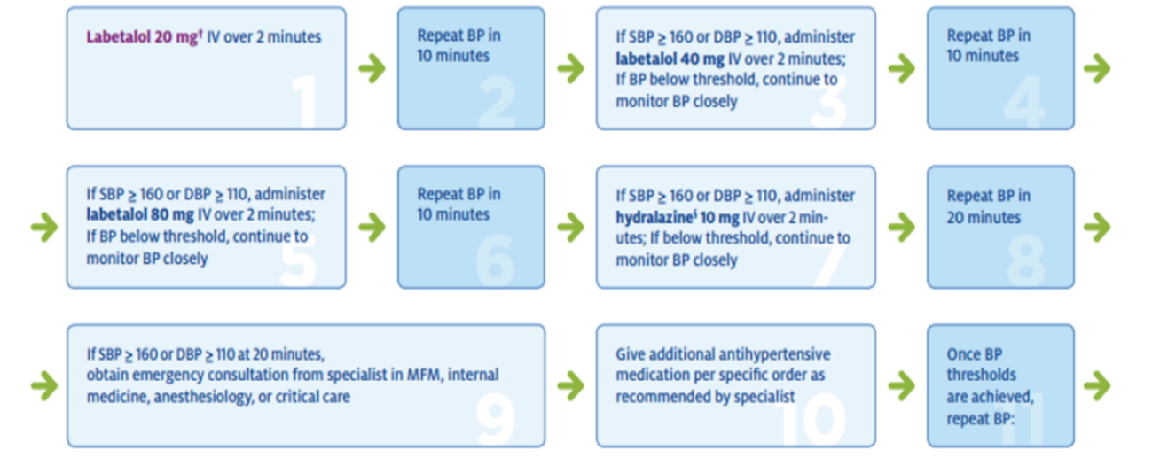

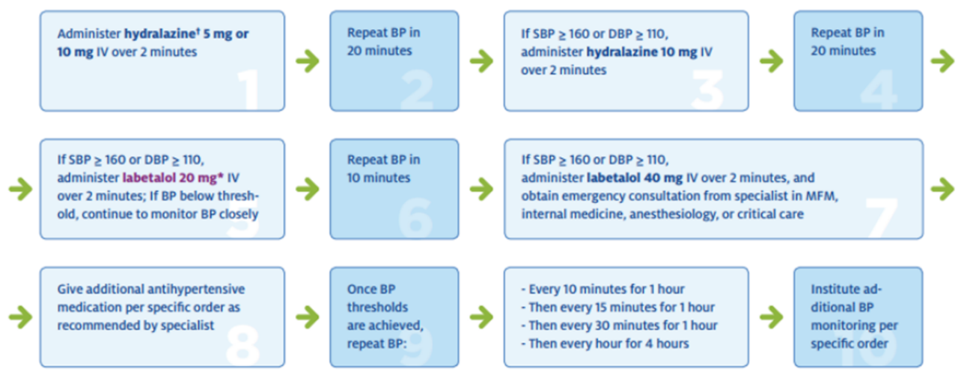
Intravenous Hydralazine administration

PBP#4
Magnesium sulfate administration for seizure prophylaxis
Implementation Strategies:
- Initiate timely (within 30-60 minutes) administration of Magnesium Sulfate infusion for all patients who are experiencing severe hypertension with high suspicion for preeclampsia for the prevention of eclamptic seizures.
- Starting magnesium sulfate should not be delayed in the setting of acute severe hypertension; it is recommended regardless of whether the patient has gestational hypertension with severe features, preeclampsia with severe features, or eclampsia.
- Dosing of Magnesium sulfate therapy for seizure prevention and treatment:
Magnesium Sulfate Administration | Loading  Dose | Maintenance  Dose | Additional recommendations
No suspected  renal impairment | 4-6 grams over 20-30 minutes | 1-2 grams per hour
Mild Renal Impairment (creatinine 1.0 – 1.5, oliguria) | 4-6 grams over 20-30 minutes | 1 gram per hour | Serum Magnesium levels every 4 hours
Unable to obtain IV access | 10-gram loading dose IM – 5 grams in each buttock | 5 grams IM every 4 hours | May mix Magnesium with 2% Xylocaine to reduce pain associated with IM injection
- For patients who are planning to deliver via cesarean section, Magnesium Sulfate infusion should ideally begin prior to surgery, continue during the surgery, and continue for 24 hours post-delivery.
- For patients who are planning to deliver vaginally, Magnesium Sulfate infusion should ideally begin during the Intrapartum period and continue for 24 hours post-delivery.
- Magnesium Sulfate is recognized as a high-alert medication and standard protocols should be developed that include the preparation, storage, alerts, and labeling of this medication. These protocols should also include the use of infusion pumps, dual signoffs, and separate doses for load and maintenance to ensure patient safety.
- Standardized education and simulation should be developed to educate clinical staff regarding accurate measurement of blood pressure, urine output, evaluation of deep tendon reflexes and clonus, and breath sounds.
- Standard protocols should be developed that provide rapid access to and guidelines for administration of magnesium sulfate. These guidelines should be readily available in all areas of the hospital that interact with women during pregnancy and the postpartum period.
- Magnesium toxicity can be prevented by confirming adequate renal function with hourly urinary output assessment (typically with the placement of a Foley catheter) and a normal serum creatinine, serial evaluation for presence of patellar deep tendons reflexes, and close observation of respiratory rate.
- Serum Magnesium Concentration and Toxicities:
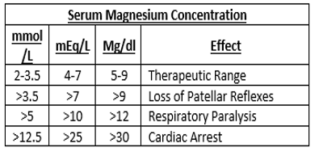
- Treatment of Magnesium toxicity Administer calcium gluconate (10 mL of 10% solution over 10 minutes or 1 gm IV)

Contraindications: Myasthenia gravis; avoid with pulmonary edema, use caution with renal failure

IV access:
- Load 4-6 gms 10% magnesium sulfate in 100 ml
- Label magnesium sulfate; Connect to labeled infusion pump
- Magnesium sulfate maintenance 1-2 gms/hour

No IV access:
- 10 grams of 50% solution IM (5 g in each buttock)

PBP#5
Immediate release oral Nifedipine (may be considered as first-line therapy, particularly when IV access is not available)
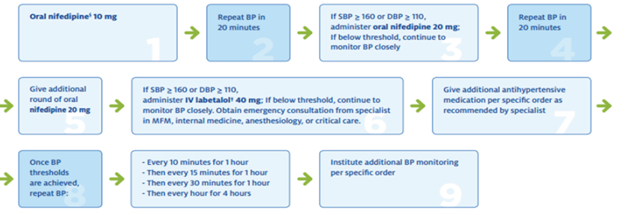

PBP#6
Documentation of care transition and education after delivery for women with gestational hypertension, preeclampsia, or eclampsia
Document all care performed in Electronic Medical Record (EMR) ²²
    - Assessments
    - Clinical issues
    - Communication with other health care professionals regarding the patient
    - Communication with and education of the patient, family, and the patient’s designated support person and other third parties
    - Medication records (MAR)
    - Order acknowledgement, implementation, and management
    - Patient clinical parameters
    - Patient responses and outcomes, including changes in the patient’s status
    - Plans of care that reflect the social and cultural framework of the patient

PBP#7
Disparity lens
To eliminate disparities associated with preeclampsia:
1. Universal adoption of AIM bundle
a. Track disparities of treatment of severe hypertension by race and ethnicity (will start in the Quality/Improvement meetings)

2. Post-partum education of the POST-BIRTH warning signs using community workers or widespread community campaigns for pregnancy and post-partum (addresses common causes of pregnancy related death in Tennessee)
a. Pain in chest
b. Obstructed breathing
c. Seizures
d. Thoughts of hurting yourself or baby
e. Bleeding
f. Incision that is not healing
g. Red or swollen leg
h. Temperature >100.4 ⁰F
i. Headache not alleviated with common analgesics or associated with vision changes
3. Treatment of hypertension post-partum with medications that are more effective in certain racial demographics.
For example, black patients respond better to thiazide diuretics and calcium channel blockers. Ace-inhibitors and Angiotensin converting enzyme inhibitors are favored in the setting of renal dysfunction and patients with diabetes
4. Blood pressure kits upon discharge with text messages as a backup for patients unable to follow up for in person clinic visits.
5. Cardiology follow up with echocardiograms (ECG) with patient with a history of severe preeclampsia if indicated, as black women are more likely to have cardiac dysfunction.
6. Home health visits antenatally and 1-2 weeks following the birth of a patient with preeclampsia postnatally.

PBP#8
Follow up after delivery; assessment of long-term diagnosis/treatment; appropriate post-partum discharge instructions

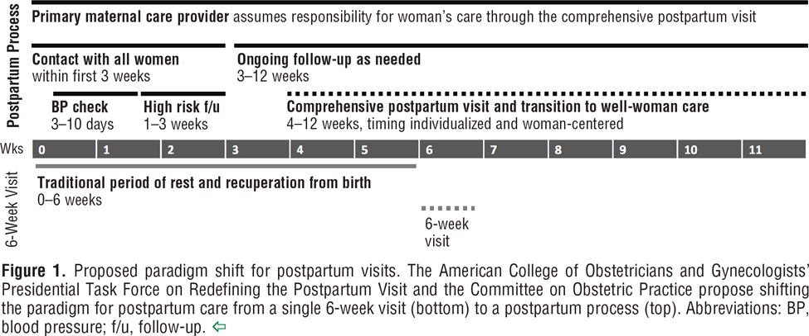
Follow-up after delivery
- Initial postpartum visit should be considered for those women with medical issues at 1-2 weeks postpartum (in person or by phone/telehealth) followed by a comprehensive visit before 12 weeks postpartum.¹²
- With the understanding that “medical issues” could include physical, mental, or psychosocial issues follow-up (either via phone or in person) for most women within 7-10 days post-delivery will increase recognition and treatment for a variety of conditions.
- For those women with new hypertension (either new or chronic), BP check is recommended in 3-10 days postpartum.
- For those women with hypertension requiring blood pressure medicine during pregnancy, close monitoring in the initial three weeks postpartum is recommended as they are at risk for hypotension with normalization of blood pressure after delivery.¹³
- Utilizing telehealth (via text message) may increase compliance with home monitoring.

* An ongoing quality improvement program at the University of Pittsburgh Medical Center focused on follow-up with hypertensive mothers. They were enrolled in a text messaging program (Vivify) and helped to procure a BP monitor as well as instructed on it use. Participants were asked to submit BP’s five (5) times a week and if those were in range, they could skip their 7-10 in person follow-up. The program had high compliance and satisfaction from those enrolled and felt more comfortable knowing a nurse was checking their health.¹⁴

Assessment of long-term diagnosis and treatment
- Those women diagnosed with a hypertensive disorder during pregnancy are at increased risk over their normotensive counterparts to develop CHTN. Therefore, those women should have increased long-term monitoring (3 months and 12 months, then annually).¹⁵

- Caution when using Nonsteroidal anti-inflammatory drugs (NSAID) for those women over the age of 30 with persistent hypertension as this may worsen that hypertension.¹⁵

Appropriate post-partum discharge instructions
- Adequate and appropriate education, regarding blood pressure monitoring and headache especially, should be done for those women with borderline blood pressures. As well as how to access medical attention with concerns.¹⁵

- If enrolling in a home monitoring/ telehealth program, instruction on accessing the application or service and how to accurately obtain a blood pressure at home is key. This will include both education on attaining an accurate blood pressure, assistance with obtaining a device for this purpose, and what to do in the case of abnormal results.

Appendix: Key Driver Diagram

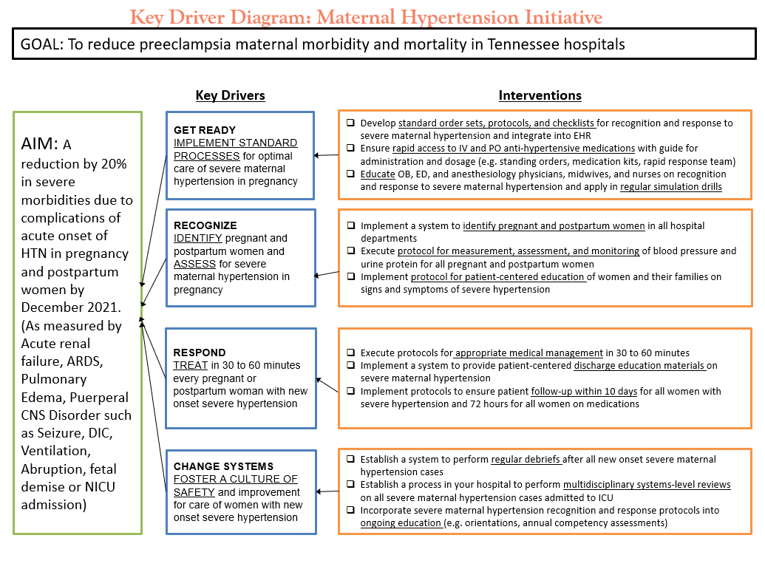
Target population: Pregnant and postpartum women (up to 6 weeks) that present to L&D, Triage, ED, Antepartum, or Postpartum that have an elevated blood pressure of ≥160 systolic and/or ≥110 diastolic twice within 15 minutes. Patients with chronic/gestational HTN should also be included.

Goal: To reduce the rate of severe morbidities in pregnant and postpartum women with severe hypertension by 20% by December 2021.

Appendix: Additional Resources

I. Patient Education Outline and Topics:
- Diagnosis
- Signs and symptoms of elevated blood pressure
  - Severe headache that does not go away
  - Nausea or vomiting
  - Confusion
  - Edema (swelling)
  - Vision changes, such as blurred or double vision
  - Pain in upper right side of your belly, or pain around your stomach
  - Making small amounts of urine
  - Sudden weight gain
  - Sometimes asymptomatic
- Treatment (depends the severity of symptoms, pregnancy, and overall general health) may include:
  - Blood pressure monitoring
  - Fetal monitoring
    - Fetal movement counting
    - Non-stress test
    - Biophysical profile
    - Doppler flow studies
  - Lab testing
  - Medication
- Risk Factors
  - African American
  - Obese
  - Stress and anxiety
  - Excessive alcohol and/or salt intake
  - Family history of high blood pressure
  - Smoking
  - Having high blood pressure before pregnancy or with a past pregnancy
  - Having kidney disease, diabetes
  - Being younger than 20 years of age or older than 35 years of age
  - Bring pregnant with multiples, such as twins or triplets
  - Family history of preeclampsia (mother or sister)
  - More than 10 years since prior pregnancy
- Pregnancy complications
  - Placental abruption
  - Poor fetal growth
  - Seizures (eclampsia)
  - Death of mother and/or baby
- Long-term complications
  - Chronic kidney disease
  - Heart attack and heart failure
  - Stroke
  - Potential long-term chronic hypertension
- How to measure blood pressure
  - Usually measured by wrapping an inflatable pressure bag connected to a mercury or digital pressure-measuring device called sphygmomanometer.
- Lifestyle changes
  - Modification
  - Weight reduction
  - Adopt Dietary Approaches to Stop Hypertension (DASH) eating plan
  - Reduction of dietary sodium intake
  - Physical activity
  - Moderation of alcohol consumption

II. Staff Education: adapted from The Joint Commission Standards for Perinatal Safety

Action and Resources | Current Assessment (Select one)
Develop written evidence-based procedures for measuring and remeasuring blood pressure. These procedures include criteria that identify patients with severely elevated blood pressure.
Need to identify women with severe range hypertension – Ensure process for timely triage and evaluation of pregnant and postpartum women with hypertension including ED, OB, ICU and outpatient areas (Triage in ED). Types of Hypertension Definitions (of severe hypertension and hypertensive emergency) Preeclampsia Early Recognition Tool  - AIM Severe Hypertension in Pregnancy E-Module Introduction  - AIM Severe Hypertension in Pregnancy E-Module Readiness  - AIM Severe Hypertension in Pregnancy E-Module Recognition  - AIM Severe Hypertension in Pregnancy E-Module Response  - AIM Severe Hypertension in Pregnancy E-Module Reporting  - AIM Treating Maternal Hypertension Webinar Recording  - AIM Treating Maternal Hypertension Webinar Slides | Need to educate on existing policies  Need to improve existing policies  Need to develop a policy
Need standard protocol for measurement and assessment of BP and urine protein for all pregnant and postpartum women  Again, utilize Preeclampsia Early Recognition Tool. Tips for taking accurate blood pressures:  - Guidance from California Collaborative on Accurate Blood Pressure Measurement (e.g. positioning, size of cuff)  - Standardize use of blood pressure devices on all units  - Regularly calibrate blood pressure devices (at least annually, if not more often)  - Ensure appropriate cuff size – width of bladder 40% of circumference and encircle 80% of arm  - Blood Pressure Visual for Best Practice & Blood Pressure Checklist | Need to educate on existing policies  Need to improve existing policies  Need to develop a policy
Develop written evidenced-based procedures for managing pregnant and postpartum patients with severe hypertension/preeclampsia.
- Determine when to treat – Ensure protocols include current criteria for initiating treatment for both severe hypertension and hypertensive emergencies (When to Treat)  - Tip: Continue to monitor patients who do not meet criteria (see #5) | Need to educate on existing policies  Need to improve existing policies  Need to develop a policy
- Ensure appropriate treatment – Protocols need to cover use of first line and second-line therapies.  - See ACOG recommendations below:  - Seizure Prophylaxis –  - Magnesium Sulfate  - First-Line Therapies –  - Intravenous Labetalol  - Intravenous Hydralazine  - Oral Nifedipine  - Second-Line Therapies – If patient fails to respond.  - Tip: Work with pharmacy to standardize medication order sets and have medications readily available in the areas where patients initially present (either in ED or OB triage area). Ideally, the medications would be bundled in the Pyxis machine. | Need to educate on existing policies  Need to improve existing policies  Need to develop a policy
- Monitoring Blood Pressure and Labs Monitoring Change of Status  - Have a plan for complications and escalation (Consultation Triggers)  - Tip: Need to have phone number readily available for closest MFM consult and/or referral. | Need to educate on existing policies  Need to improve existing policies  Need to develop a policy
- Postpartum Surveillance-need to have a plan for inpatients and outpatients | Need to educate on existing policies  Need to improve existing policies  Need to develop a policy
Other helpful information:  Minimal requirements for standard process starting with initial presentation at your hospital:  - Notification of physician or primary care provider if systolic BP =/≥ 160 or Diastolic BP =/≥ 110 for two measurements within 15 minutes apart  - After the second elevated reading, treatment should be initiated ASAP (ideally within 60 minutes of verification)  - Process must include timing for use of magnesium sulfate therapy  - Process for escalation measures for those unresponsive to standard treatment  - Describe manner and verification of postpartum follow up within 7 to 10 days of birth  - Describe postpartum education  - Hypertensive Emergency Checklist  - Eclampsia Checklist  - ED Postpartum Preeclampsia Checklist | Need to educate on existing policies  Need to improve existing policies  Need to develop a policy
Provide role-specific education to all staff and providers who treat pregnant/postpartum patients about the hospital’s evidence based severe hypertension/preeclampsia procedure. At a minimum, education occurs at orientation, whenever changes to the procedure occur, or every two years.
- Ensure appropriate education for all staff – Training should occur at initial hiring and in annual competency training.  - Be sure to include:  - OB staff  - ED staff  - Other staff (such as outpatient clinics)  - PowerPoint Presentation (link)  - E-modules (ACOG link) | Need to educate on existing policies  Need to improve existing policies  Need to develop a policy
Conduct drills at least annually to determine system issues as part of ongoing quality improvement efforts. Severe Hypertension/preeclampsia drills include a team debrief.
- Ensure drills/simulations conducted for all staff  - Several simulations from ACOG:  - Eclampsia Simulation Scenario Overview  - Eclampsia Drill Clinical Scenario  - Eclampsia Drill Assessment Tool | Need to educate on existing policies  Need to improve existing policies  Need to develop a policy
- Review severe hypertension/preeclampsia cases that meet criteria established by the hospital to evaluate the effectiveness of the care, treatment, and services provided to the patient during the event.
- Develop criteria and frequency for reviewing severe cases and understanding ways to improve.  - Debriefing Tool (TIPQC) to debrief and evaluate severe range cases | Need to educate on existing policies  Need to improve existing policies  Need to develop a policy
- Provide printed education to patients (and their families including the designated support person whenever possible).
- Develop protocol for patient Discharge Planning and Follow-Up  - What patients need to know – Prenatal and Postpartum Patient Counseling or Education  - Helpful Patient Video Fact sheet from American  - Organization of Nurse Executives (scroll down to “Save your Life Handouts”)  - Patient Education Pamphlets sold by the Preeclampsia Foundation | Need to educate on existing policies  Need to improve existing policies  Need to develop a policy

References

1. Tsigas, Eleni. Postpartum Preeclampsia: Risk after Delivery Remains. 28 May 2019. https://www.dona.org/postpartum-preeclampsia-risk-after-delivery-remains/. 2 July 2020.
2. Lui, Nicla A., Gajana Jeyaram and Amanda Henry. "Postpartum Interventions to Reduce Long-Term Cardiovascular Disease Risk in Women After Hypertensive Disorders of Pregnancy: A Systematic Review." Front. Cardiovasc. Med., (2019): https://doi.org/10.3389/fcvm.2019.00160.
3. Stevens, Warren, et al. "Short-term costs of preeclampsia to the United States health care system." American Journal of Obstetrics & Gynecology (2017): 217 (3). DOI: 10.1016/j.ajog.2017.04.032 .
4. Levine, Lisa D., et al. "Persistent cardiac dysfunction on echocardiography in African Amercian women with severe preeclampsia." Pregnancy Hypertension (2019): 17: 127–132. doi:10.1016/j.preghy.2019.05.021.
5. CDC. "CDC/National Center for Health Statistics: Tennessee." 24 April 2020. Centers for Disease Control and Prevention. https://www.cdc.gov/nchs/pressroom/states/tennessee/tn.htm.
6. Saeed , Anum, Dave Dixon and Eugene Yang. "Racial Disparities in Hypertension Prevalence and Management: A Crisis Control?" 6 April 2020. American College of Cardiology. https://www.acc.org/latest-in-cardiology/articles/2020/04/06/08/53/racial-disparities-in-hypertension-prevalence-and-management.
7. Schiff E, Peleg E, Goldenberg M, Rosenthal T, Ruppin E, Tamarkin M, et al. The use of aspirin to prevent pregnancy-induced hypertension and lower the ratio of thromboxane A2 to prostacyclin in relatively high-risk pregnancies. N Engl J Med 1989; 321:351–6. (Level I)
8. Roberge S, Nicolaides K, Demers S, Hyett J, Chaillet N, Bujold E. The role of aspirin dose on the prevention of preeclampsia and fetal growth restriction: systematic review and meta-analysis. Am J Obstet Gynecol 2017; 216:110–20. e6. (Systematic Review and Meta-Analysis)
9. Meher S, Duley L, Hunter K, Askie L. Antiplatelet therapy before or after 16 weeks’ gestation for preventing preeclampsia: an individual participant data meta-analysis. Am J Obstet Gynecol 2017; 216:121–8.e2. (Systematic Review and Meta-Analysis)
10. LeFevre, ML. U.S. Preventative Services Task Force. Low-dose aspirin use for the prevention of morbidity and mortality from preeclampsia. U.S. Preventative Services Task Force Recommendation Statement. Ann Intern Med 2014; 161(11);819-26
11. ACOG Committee Opinion 743 “Low-Dose Aspirin Use During Pregnancy.” Am J Obstet Gynecol 2018;132(1)e44-e52
12. Berens et al. Overview of the postpartum period: Normal physiology and routine maternal care: accessed on 6/15/2020 Berens et al
13. August et al. Use of antihypertensive drugs during pregnancy and postpartum: UpToDate accessed on 6/15/2020
14. Hauspurg et al. A postpartum remote hypertension monitoring protocol implemented at the hospital level. Obstetrics and Gynecology 2019:134 685-91
15. August et al. Use of antihypertensive drugs during pregnancy and postpartum: UpToDate accessed 6/15/2020
16. ACOG Practice Bulletin 222 “Gestational Hypertension and Preeclampsia.” June 2020
17. ACOG. "Chronic Hypertension in Pregnancy. Practice Bulletin No. 203." January 2019. American College of Obstetricians and Gynecologists . https://www.acog.org/clinical/clinical-guidance/practice-bulletin/articles/2019/01/chronic-hypertension-in-pregnancy.
18. Cedars Sinai. "Gestational Hypertension." 2020. cedars-sinai.org. https://www.cedars-sinai.org/health-library/diseases-and-conditions/g/gestational-hypertension.html.
19. Geiger, H. Jack, et al. "Institute of Medicine (US) Committee on Understanding and Eliminating Racial and Ethnic Disparities in Health Care." Institue of Medicine (IOM) of The National Academies (2003): https://www.ncbi.nlm.nih.gov/books/NBK220358/ doi: 10.17226/12875. National Academies Press (US).
20. Jones, Emily J., et al. "Continued disparities in postpartum follow-up and screening among women with gestational diabetes and hypertensive disorders of pregnancy: A systematic review." J Perinat Neonatal Nurs (2019): 33(2): 136–148. doi:10.1097/JPN.0000000000000399.
21. Mata-Greenwood, Eugenia and Dong-Bao Chen. "Racial Differences in Nitric Oxide-Dependent Vasorelaxation." Reprod Sci (2008): 15(1): 9–25. National Institutes of Health.
22. American Nurses Association (ANA). "Principles in Nursing Documentation: Guidance for Registered Nurses (2010). www.nursingworld.org
23. Medically indicated late-preterm and early-term deliveries. ACOG Committee Opinion No. 764. American College of Obstetricians and Gynecologists. Obstet Gynecol 2019;133: e151–55

